How to logon to your Office365 account
- Logon to your computer & open internet browser (eg Chrome)
- Enter in URL or Ctrl+click on this link: www.office.com
- Click on ‘SIGN IN” & enter your full email address:
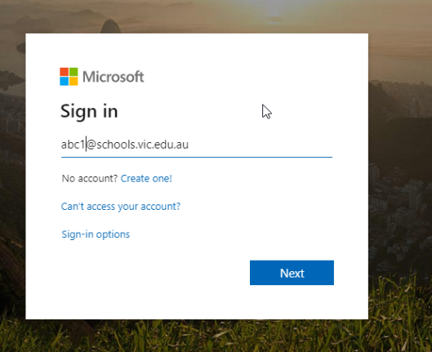
your username@schools.vic.edu.au
- Click on ‘NEXT’
- You will be redirected to your school’s organization page
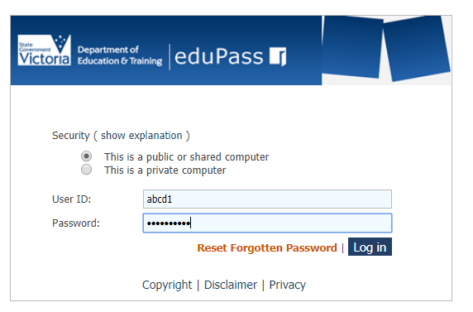
- Logon to eduPass with your current school username & password

- Office 365 will open up with access to several software you can use as long as
you have internet access.
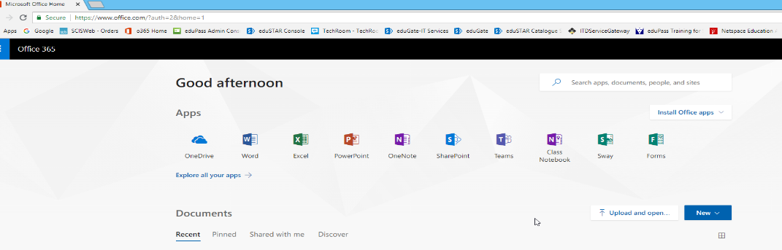

Must read – Username formats!
Your eduPass (student) username has two formats:
- Simple student username to login on eduPass webpage: abcd1 (your computer logon user name)
- Full student username to login on Office365 webpage: abcd1@schools.vic.edu.au
This means, your full Office365 email address is: abcd1@schools.vic.edu.au

